Login to your PATCHS account and This will load the **How can we help you?**page where you need to click the **Myself**button.

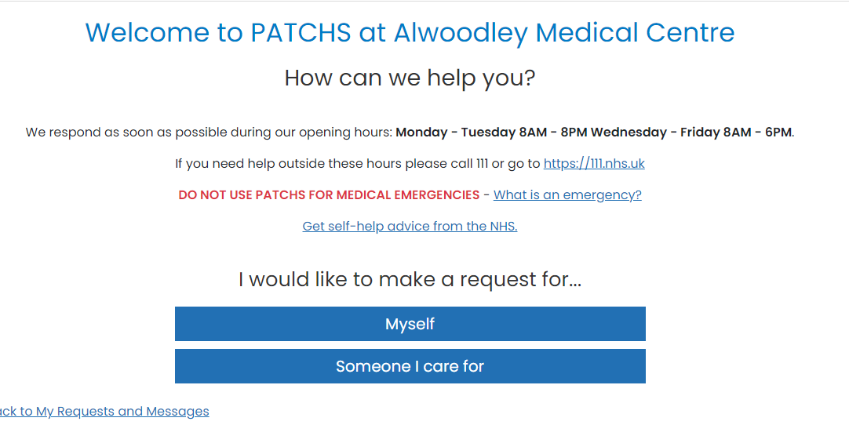

You can then click on the button that best describes your type of request. Do not select Other, Admin request for any medical/clinical problem – This will not been seen by the GP.

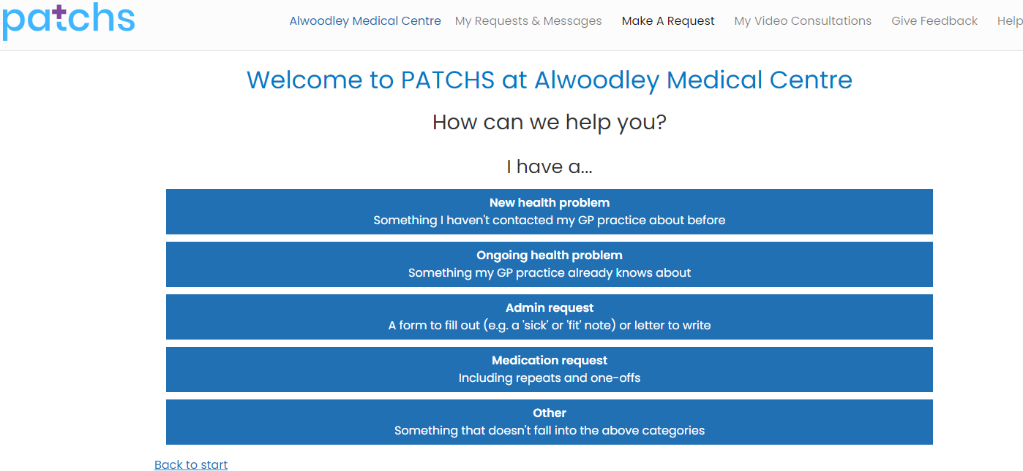

You will then see 3 warning messages - Emergency warning.

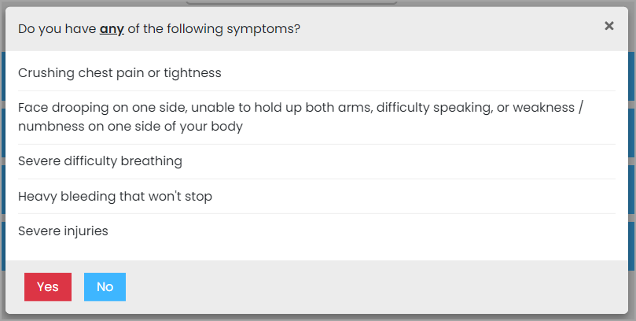

Confirm Detail

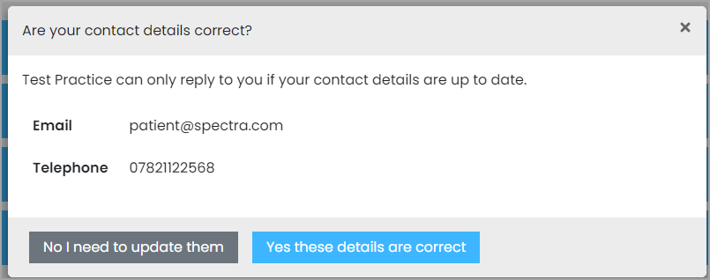

Completion time

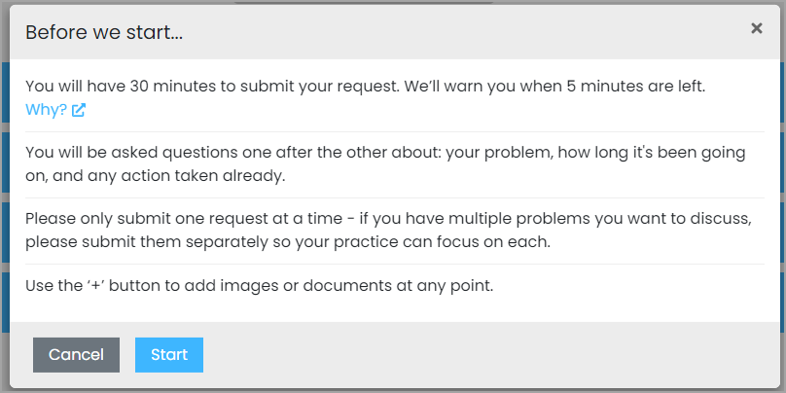

After which you will be taken to the PATCHS chatbot where you will be asked a few quick questions to help your GP understand more about your request. Answer each question in turn, using the **Submit**button when each response is complete.  
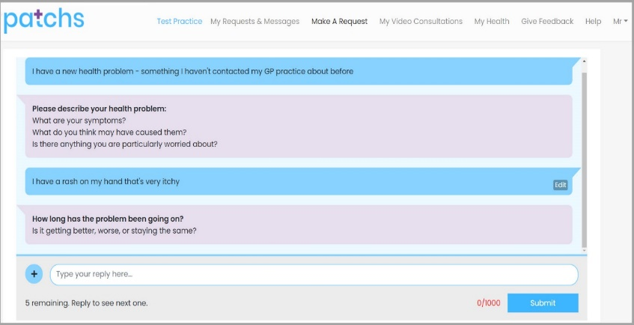

The **Edit** button is shown alongside each response.

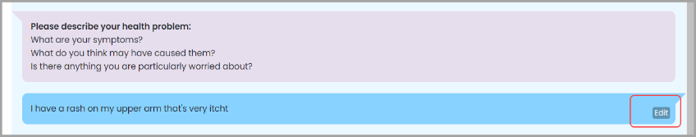

Click Edit - allows you to edit your individual responses from within the chatbot.

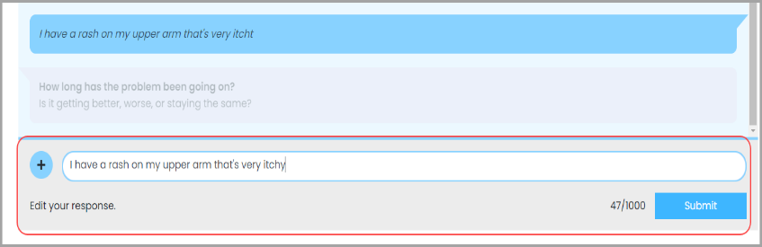

You can click the **+ Button** alongside the text box to add an image to your response. This loads the **Attach Image or document**box where you can select an image or file to upload.  You should only upload sensitive images if you are asked by your GP. If it is a sensitive image, you can mark it as such, and it will not be displayed to anyone except the GP.

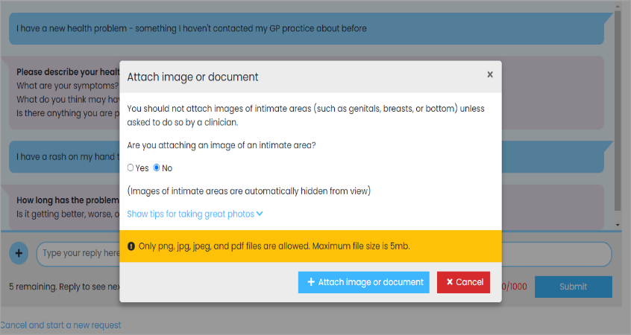

When you have answered and edited all your responses you will be asked to **confirm** your responses and agree for them to be added to your GP record.

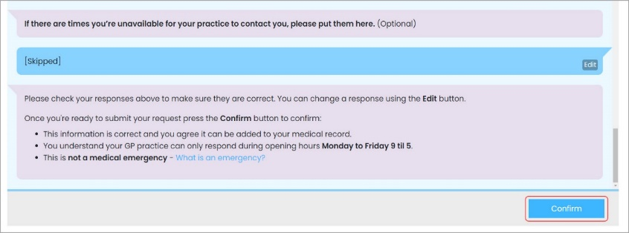

Click the **Confirm**button to send your request to the practice. A confirmation email will be sent to you and to the GP practice to respond to your request.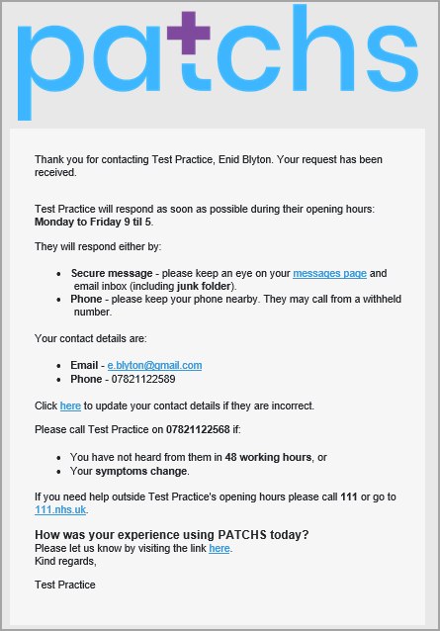

You can also enter feedback on your experience of PATCHS. This helps us improve the service and identify if there are any problems.

If you want to check on the progress of your request or need to respond to a follow up question from the practice, sign back into your PATCHS account to access your inbox or click the link you have received through text.

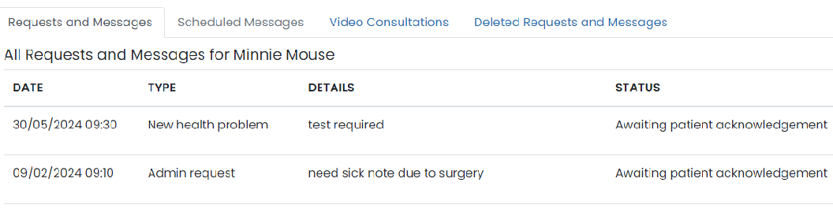

This will then display your conversation with the practice where you can respond to follow up questions if you are requested to do so by the practice.

