You can submit requests to PATCHS on behalf of people that you care for provided that the person you are submitting it for is registered at the practice and you are the patients main care giver (mum, Dad, Power of attorney and carer for elderly person).

First click on the **Make a Request**link at the top of the page. This will load the **How can we help you?**page where you need to click the **Someone I care for**button.

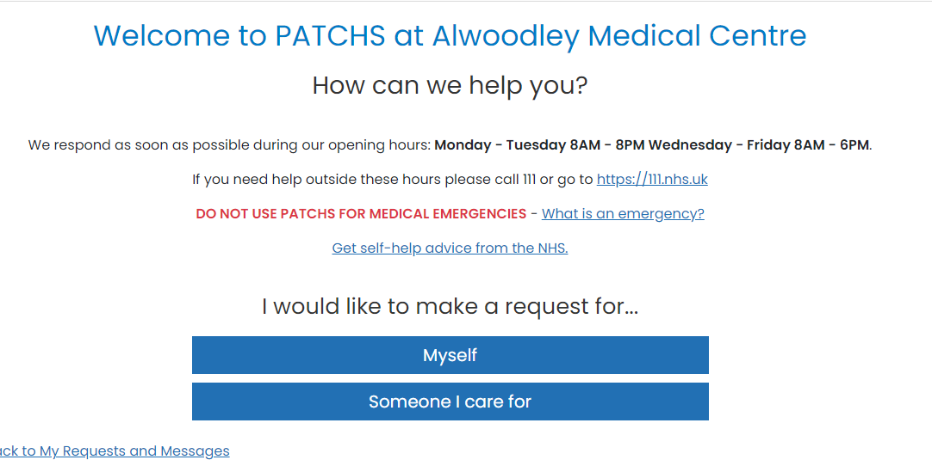

This will take you to the **Choose Dependent**page where you choose a dependent from a list (if they have already been set up) or add someone new by clicking on the **Add someone I care for**link.

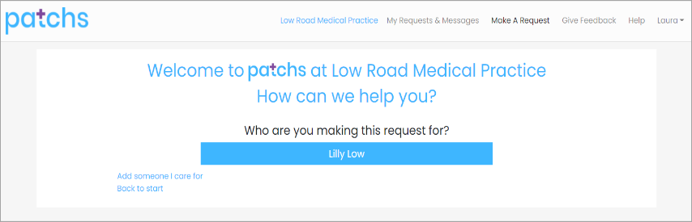

Clicking the **‘Add someone I care for’** link takes you to the **Add Dependents**page. You can then enter the details of the person you are caring for, confirm that this person is registered at this GP practice, and that you are authorised to act in the capacity of parent or carer for this person. Then click the **Add**button**.  
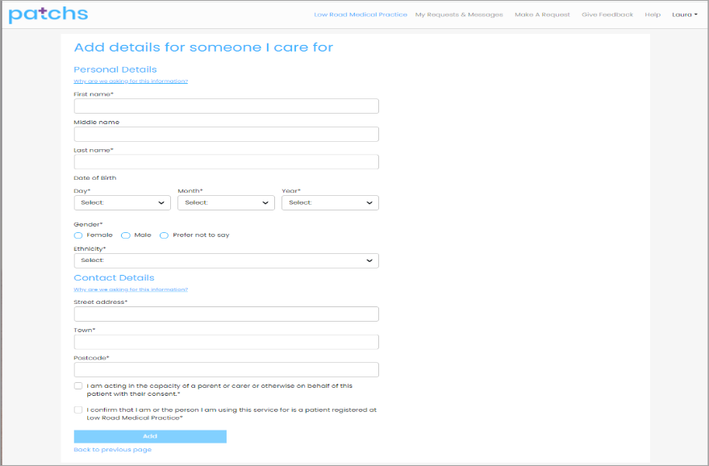**

Now select the dependent from the **Choose Dependent**page.

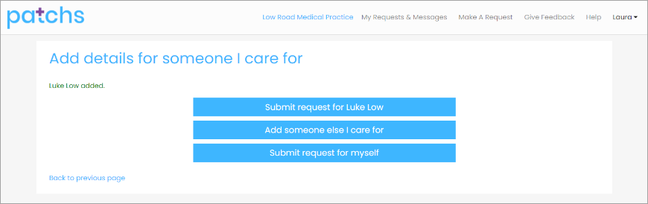

This will take you to the **Request Contact**page where you can click on the button that best describes your type of request.  
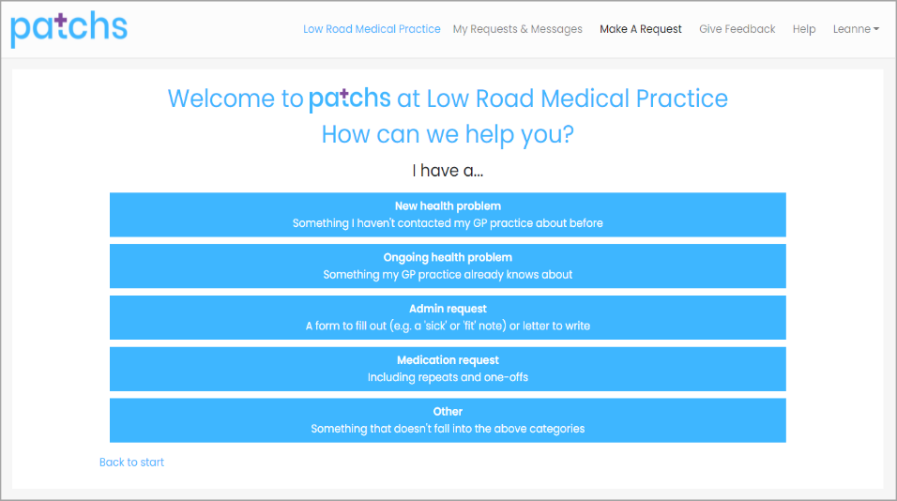

You will then see 3 warning messages Emergency warning.

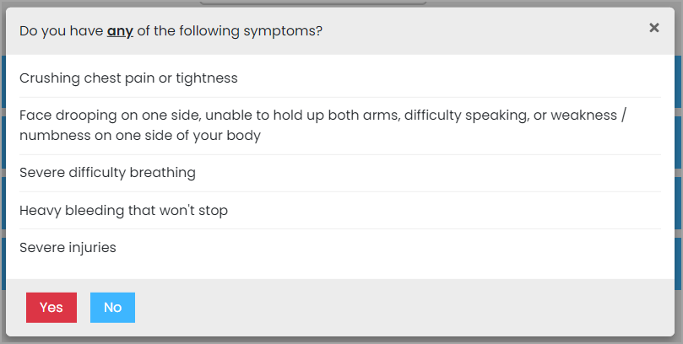

Confirm details.

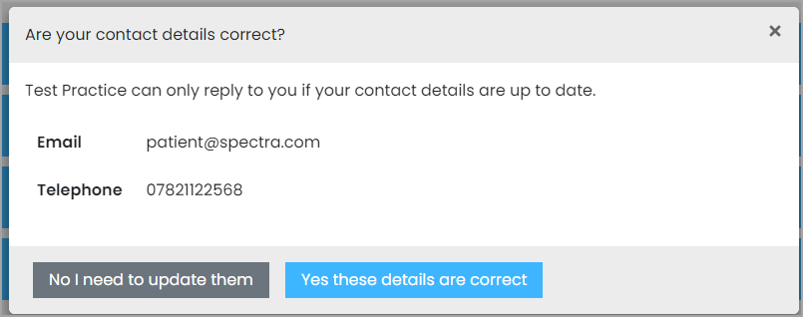

Completion time

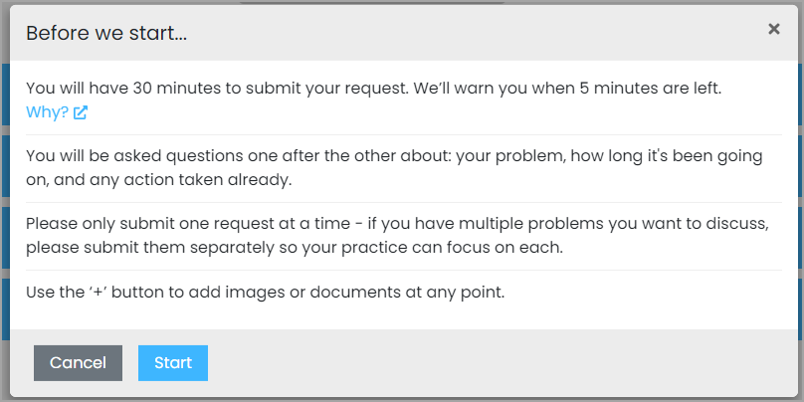

After which you will be taken to the PATCHS chatbot where you will be asked a few quick questions to help your GP understand more about your request. Answer each question in turn, using the **Submit**button when each response is complete.

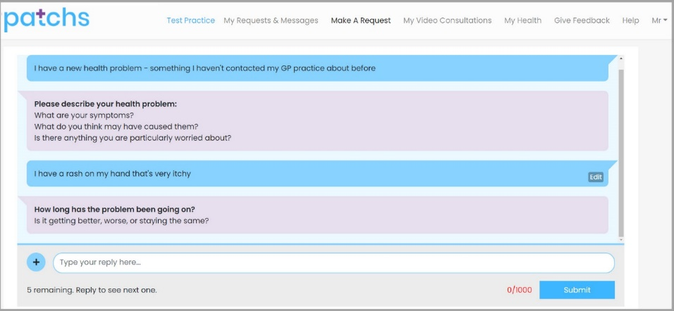

The **Edit** button is shown alongside each response.

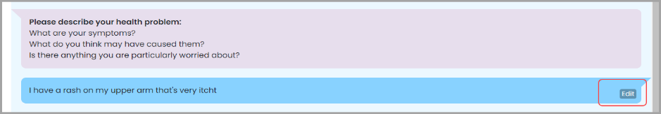

You can click the **+ Button** alongside the text box to add an image to your response. This loads the **Attach Image or document**box where you can select an image or file to upload.  You should only upload sensitive images if you are asked by your GP. If it is a sensitive image, you can mark it as such, and it will not be displayed to anyone except the GP.

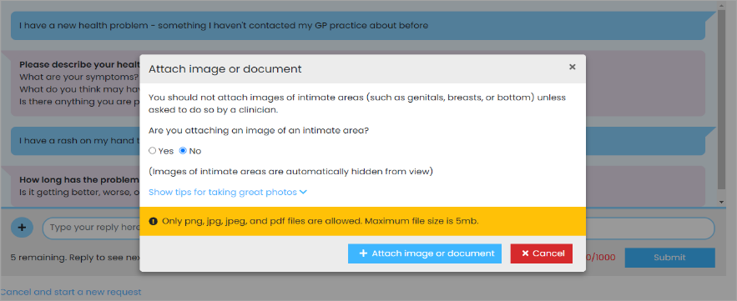

When you have answered and edited all your responses you will be asked to **confirm** your responses and agree for them to be added to your GP record.

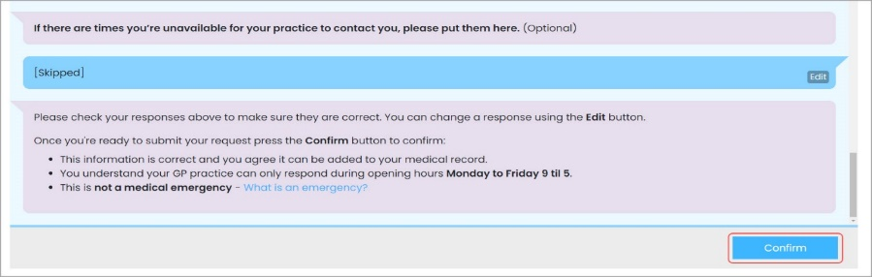

Click the **Confirm**button to send your request to the practice. A confirmation email will be sent to you and to the GP practice to respond to your request.

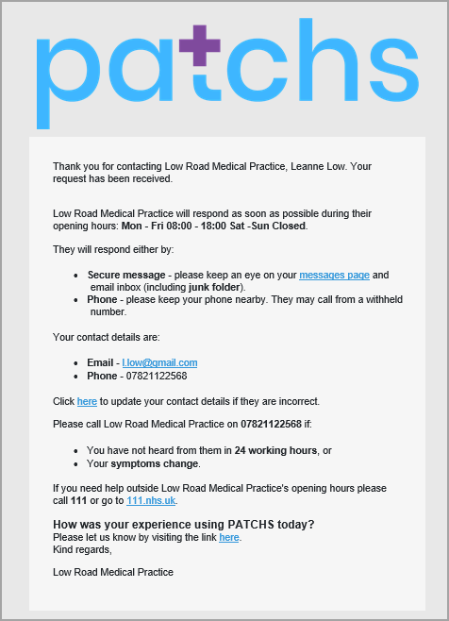

If you want to check on the progress of your request or need to respond to a follow up question from the practice, you can click the **'My Requests & Messages'**link to view your requests; this also shows past requests. From here you can click the **View**button next to the relevant request.

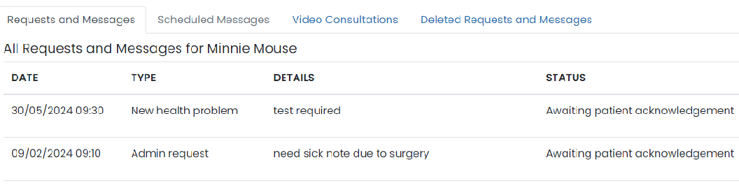

This will display your conversation with the practice and is where you can respond to follow up questions if you are asked to do so by the practice.

