Follow the PATCHS link on Alwoodley Medical centre website - the screenshot below shows this links to open PATCHS to register. Click on either Online consultation or under most popular services Online consultation – contact your GP online via PATCHS (see below highlighted in red).

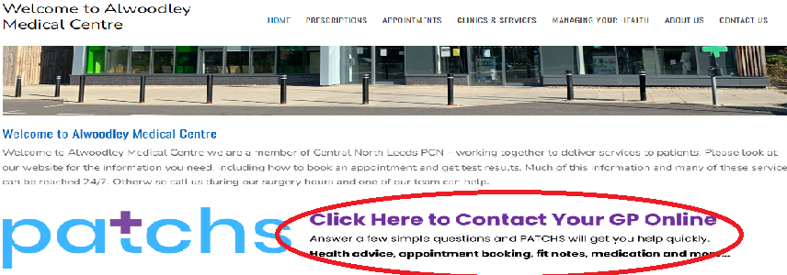

This will open the PATCHS information on the website, gives you advise on what PATCHS can be used for and will allow you to register for the service. To register for the PATCHS Service click on click here which is highlight below.

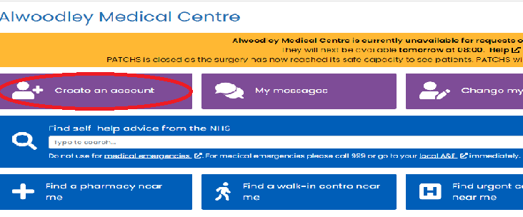

This will then open a new window showing the PATCHS system for Alwoodley Medical Centre asking you to create an account.

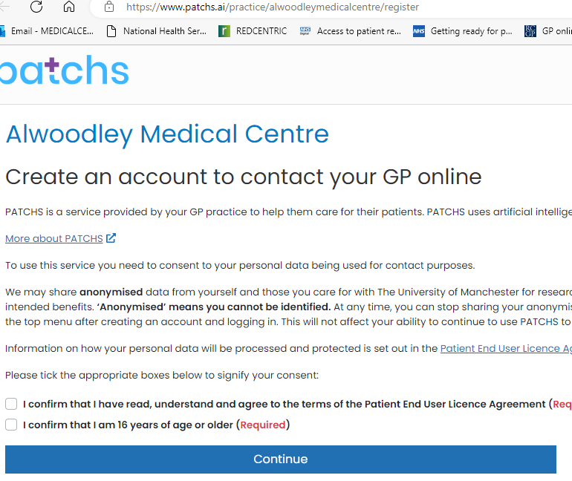

To create an account please confirm the tick boxes and select continue.

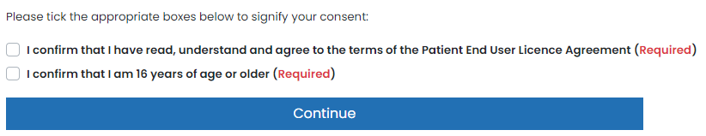

Once you have selected continue PATCHS will open a new window asking for your information and to create a password for PATCHS, please fill this in as correctly as possible, as this allows the PATCHS system to find your medical records.

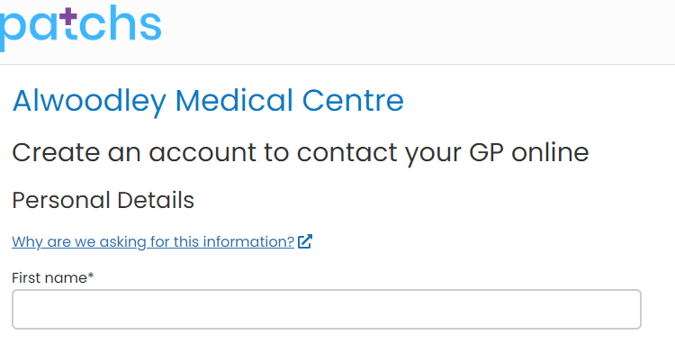

Once you have filled in and registered for the PATCHS System a new page will open advising you are now registered.

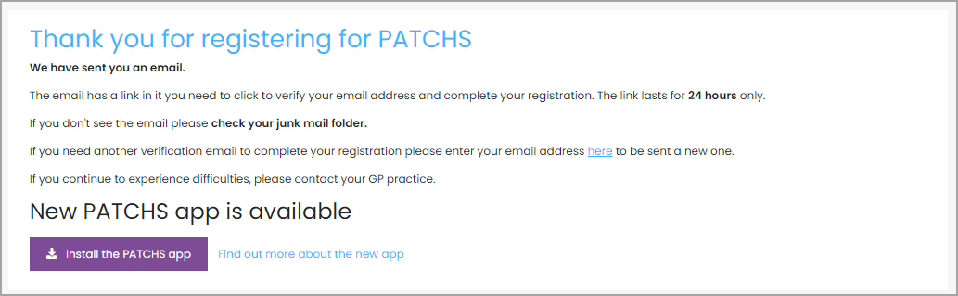

You will now receive an email from PATCHS that contains a **'registration completion' link**. (If you don’t receive the email within 5 minutes, please check you Junk email folder. If it's not there, please try to register again and check your email address is correct).

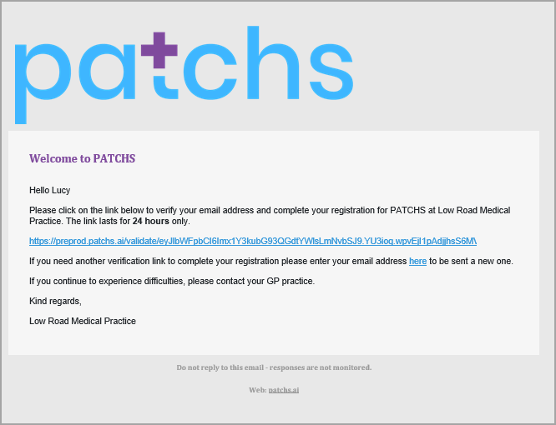

Clicking on the link will complete the registration and allow you to submit a request to your practice.

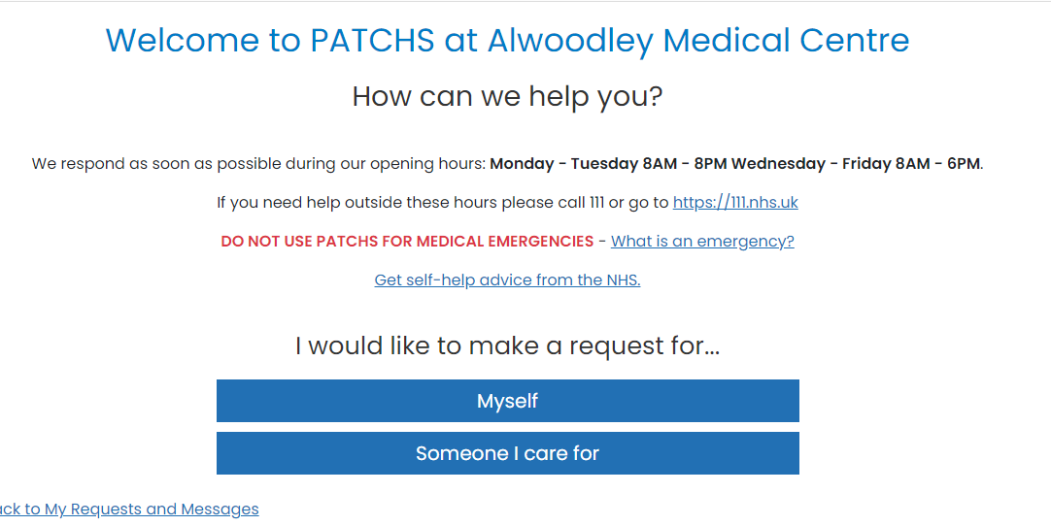

This will now allow you to contact the surgery through PATCHS. You can submit a request to the Surgery through PATCHS.